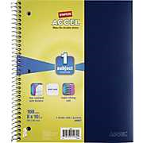
3rd GRADE ELA SUPPLIES

- One pkg. of sharpened #2 pencils

- One durable notebook with lined paper
- One box of tissues

- Two packages of 8 colored tab
dividers

3rd GRADE MATH SUPPLIES

- One pkg. of sharpened #2 pencils

- One box of tissues

- One 1 1/2’” three ring binder

- One 6 pack of dry erase markers

- One package of index tab dividers (6 count or larger)

- At least 3 different colored highlighters

- One pair of student scissors

- One small pencil box

Homeroom Wish List

Please consider donating the following items to your child’s homeroom classroom. Thank you for your generosity!

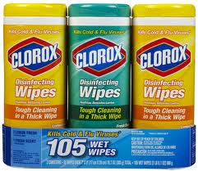
- Clorox wipes

- Hand sanitizer

- Amazon/Wal-Mart gift cards for
classroom library/supplies
(Purchases will be listed on monthly newsletter.)
- Extra tissues

- Extra sharpened pencils

